**Design Thinking Project Workbook**

**Don't find customers for your product but find products for your customers**

**1. Team**

**Team Name:**

**Team Logo (if any):**

**Team Members:**

1. [VASIREDDY HARSHINI CHOWDARY,2320040074]
2. [K. SINDHU, 2320040034]

**2. Problem/Opportunity Domain**

**Domain of Interest:** Music streaming industry with a focus on **emotion-driven music recommendations**.

**Description of the Domain:** The music streaming industry is saturated with content, making it difficult for users to find songs that match their emotional needs. Current algorithms focus on past behavior but often fail to recommend music based on real-time emotional feedback.

**Challenges:**

* Overwhelming choice leading to decision fatigue.
* Lack of emotional nuance in current recommendation systems.

**Opportunities:**

* AI-driven recommendations based on real-time emotional feedback.
* Enhanced user engagement and potential collaborations in mental health.

**Why did you choose this domain?:** This domain was selected due to its **market potential** and the opportunity to improve **user experience** and **mental well-being** through personalized, emotion-based music recommendations.

**3. Problem/Opportunity Statement**

**Problem Statement:** Users struggle to find music that aligns with their emotions due to the overwhelming amount of choices on streaming platforms.

**Problem Description:** Current music recommendation systems lack emotional depth, making it difficult for users to discover songs that match their mood in real-time, leading to frustration and decision fatigue.

**Context (When does the problem occur):** The problem arises when users seek music for specific emotional needs (e.g., relaxation, motivation, comfort) but are inundated with generic or irrelevant suggestions.

**Alternatives (What does the customer do to fix the problem):**

Customers either spend time manually searching for music, rely on mood-based playlists, or stick to familiar songs.

**Customers (Who has the problem most often):** Casual music listeners, mood-based users, and those seeking emotional relief through music.

**Emotional Impact (How does the customer feel):** Frustration, fatigue, and dissatisfaction due to the inability to easily find music that resonates with their emotional state.

**Quantifiable Impact (What is the measurable impact:** Time wasted searching for appropriate songs; decreased user engagement with streaming platforms.

**Alternative Shortcomings (What are the disadvantages of the alternatives):** Manual searching is time-consuming, and mood-based playlists are often too broad to meet specific emotional needs.

**Any Video or Images to showcase the problem:** No specific links available, but user experiences could be visually illustrated through typical music search journeys showing frustration and inefficiency.

**3. Addressing SDGs**

**Relevant Sustainable Development Goals (SDGs):**

• SDG 3: Good Health and Well-Being

• SDG 8: Decent Work and Economic Growth

• SDG 9: Industry, Innovation, and Infrastructure

**How does your problem/opportunity address these SDGs?:**

• **SDG 3**: By offering personalized, emotionally tailored music recommendations, the solution enhances **mental well-being**, reducing stress and anxiety through music.

• **SDG 8**: The tool promotes **growth in the music streaming industry**, potentially leading to job creation and increased economic activity, especially in AI development and music tech.

• **SDG 9**: This project fosters **innovation** by applying AI to improve user experience in the music industry, contributing to technological advancements and infrastructure in music streaming.

**4. Stakeholders**

Answer these below questions to understand the stakeholder related to your project

1. **Who are the key stakeholders involved in or affected by this project?**

• **Music listeners** (end users seeking emotional resonance in music)

• **Music streaming platforms** (Spotify, Apple Music, etc.)

• **AI developers** and tech companies involved in creating the recommendation system

• **Mental health advocates and organizations** interested in the emotional benefits of music

• **Music creators/artists** whose work may reach more emotionally targeted audiences

1. **What roles do the stakeholders play in the success of the innovation?**

• **Listeners** provide the data and emotional feedback that drive the AI recommendations.

• **Streaming platforms** integrate the AI system into their services.

• **AI developers** build and optimize the recommendation tool.

• **Mental health organizations** could promote the use of music as a mental well-being tool.

• **Artists** benefit from exposure to targeted audiences who resonate with their music.

1. **What are the main interests and concerns of each stakeholder?**

• **Listeners**: Finding music that resonates with their emotions without wasting time.

• **Streaming platforms**: Enhancing user engagement and retention.

• **AI developers**: Creating accurate, effective algorithms for emotional recommendations.

• **Mental health advocates**: Ensuring the tool is beneficial for emotional well-being.

• **Artists**: Reaching a broader, more emotionally connected audience.

1. **How much influence does each stakeholder have on the outcome of the project?**

• **High influence**: Streaming platforms, AI developers, and listeners, as their collaboration determines the success of the system.

• **Medium influence**: Mental health organizations, since they could validate or promote the benefits.

• **Medium influence**: Artists, who are essential for providing content but have less control over platform integration.

1. **What is the level of engagement or support expected from each stakeholder?**

• **High**: Streaming platforms and AI developers need to be actively involved in the integration and development process.

• **Moderate**: Listeners will need to engage with the tool and provide feedback.

• **Low to moderate**: Mental health organizations may promote it but aren't directly involved in development.

• **Low**: Artists will indirectly benefit from the project.

1. **Are there any conflicts of interest between stakeholders? If so, how can they be addressed?**

• **Possible conflict** between **artists and platforms** over song exposure and royalties. This can be addressed by ensuring transparent and fair algorithms that promote diverse music, not just popular artists.

• **Data privacy concerns** from users and platforms, addressed by maintaining strict data protection and privacy protocols.

1. **How will you communicate and collaborate with stakeholders throughout the project?**

• Regular **meetings** and updates with streaming platforms and AI developers.

• **Feedback loops** from users to refine the system.

• Collaboration with **mental health organizations** through outreach and shared research.

1. **What potential risks do stakeholders bring to the project, and how can these be mitigated?**

• **Streaming platforms** may be slow to adopt new technologies—this can be mitigated by demonstrating clear user benefits and market potential.

• **AI developers** may face challenges in accurate emotional recognition—investing in continuous research and testing will mitigate this risk.

• **Privacy concerns** can arise with emotional data collection, which should be mitigated by prioritizing strong data security and ethical AI usage.

**5. Power Interest Matrix of Stakeholders**

**Power Interest Matrix: Provide a diagrammatic representation of Power Interest Matrix**

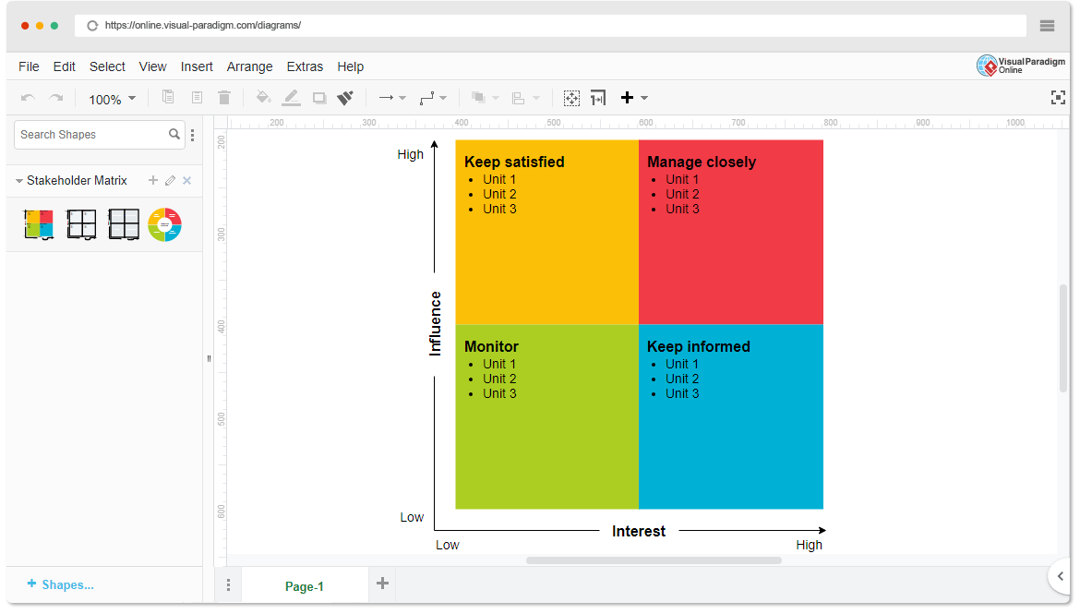

* High Power, High Interest: [Stakeholder Names]

• **Music Streaming Platforms** (e.g., Spotify, Apple Music)

• **AI Developers** (tech companies building the recommendation tool)

* High Power, Low Interest: [Stakeholder Names]

• **Mental Health Organizations** (may support but not directly involved in development)

**Regulatory Bodies** (concerned with privacy and ethical AI use)

* Low Power, High Interest: [Stakeholder Names]

• **Music Listeners** (end users seeking personalized music experiences)

• **Music Creators/Artists** (interested in reaching more relevant audiences)

* Low Power, Low Interest: [Stakeholder Name]
  1. **General Public** (those not actively involved in music streaming or AI development)
  2. **Investors not involved in tech or music sectors** (have minimal impact unless specifically interested in the music/tech market)

1. **Empathetic Interviews**

**Conduct Skilled interview with at least 30 citizens/Users by asking open ended questions (What, why/How etc) and list the insights as per the format below**

|  |  |  |
| --- | --- | --- |
| **I need to know**  **(thoughts, feelings, actions)** | **Questions I will ask**  **(open questions)** | **Insights I hope to gain** |
| Thoughts | How do you feel when you're trying to find the right music for your current mood or emotional state? | Understanding their opinions on the effectiveness of current recommendation algorithms. |
|  | What factors influence the type of music you choose to listen to at any given time? | Identifying key influences behind their music selections (e.g., mood, genre, artist). |
|  | How do you feel about AI recommending music based on your emotions or past behavior? | Insights into their perceptions of AI-driven personalization and trust in these systems. |
| Feelings | How do you feel when you're trying to find the right music for your current mood or emotional state? | Understanding frustration, satisfaction, or indifference when searching for emotionally fitting music. |
|  | How do you feel about discovering new music on streaming platforms? Is it easy, difficult, or overwhelming? | Gauging emotions around the discovery process, from excitement to overwhelm. |
|  | When listening to music, do you feel your emotional needs are being fully addressed? Why or why not? | Understanding if users feel emotionally satisfied with their current music options and recommendations. |
| actions | What do you usually do when you're in a specific mood and want to find music that fits it? | Insights into their behaviors (e.g., browsing playlists, searching by keywords) when finding mood-specific music. |
|  | How often do you use mood-based playlists or rely on music recommendations for your listening? | Discover how frequently they engage with mood-based suggestions, and whether they find them helpful. |
|  | If you can't find music that fits your emotional state, what do you do next? | Understanding what they do when current systems fail (e.g., stick to known songs, switch platforms). |

**SKILLED INTERVIEW REPORT**

**(Examples are given. Erase them and fill with your user information.)**

|  |  |  |
| --- | --- | --- |
| **User/Interviewee** | **Questions Asked** | **Insights gained (NOT THEIR ANSWERS)** |
| Priya S., Casual Listener | How do you feel when trying to find music that matches your mood? | Users feel frustrated when searching for mood-based music, as current recommendations often miss the mark emotionally. |
| David R., Music Enthusiast | How often do you rely on AI recommendations for finding new music? | Users like David who listen to music frequently don’t trust AI fully and prefer to discover music through personal exploration. |
| Lina M., Mood-Based Listener | What do you usually do when you want music that fits your emotional state? | Mood-based users tend to rely on existing playlists but feel they are often too broad and not specific to their exact emotional needs. |
| Ravi K., Busy Professional | How much time do you spend searching for music that fits your mood? | Time-constrained users struggle to find suitable music quickly and often stick to familiar playlists to avoid wasting time. |
| Sophia J., Occasional Listener | How do you feel about AI making emotional music recommendations for you? | Some users are open to AI recommendations, but there's skepticism about how well AI can understand complex emotional needs. |

**Key Insights Gained:**

* **Insight 1:** Many users feel that current recommendation systems fail to fully capture their emotional states, leading to frustration during music discovery.
* **Insight 2:** There is a mix of skepticism and openness toward AI-driven emotional music recommendations, with trust being a key barrier for some listeners.

**Empathy Map**

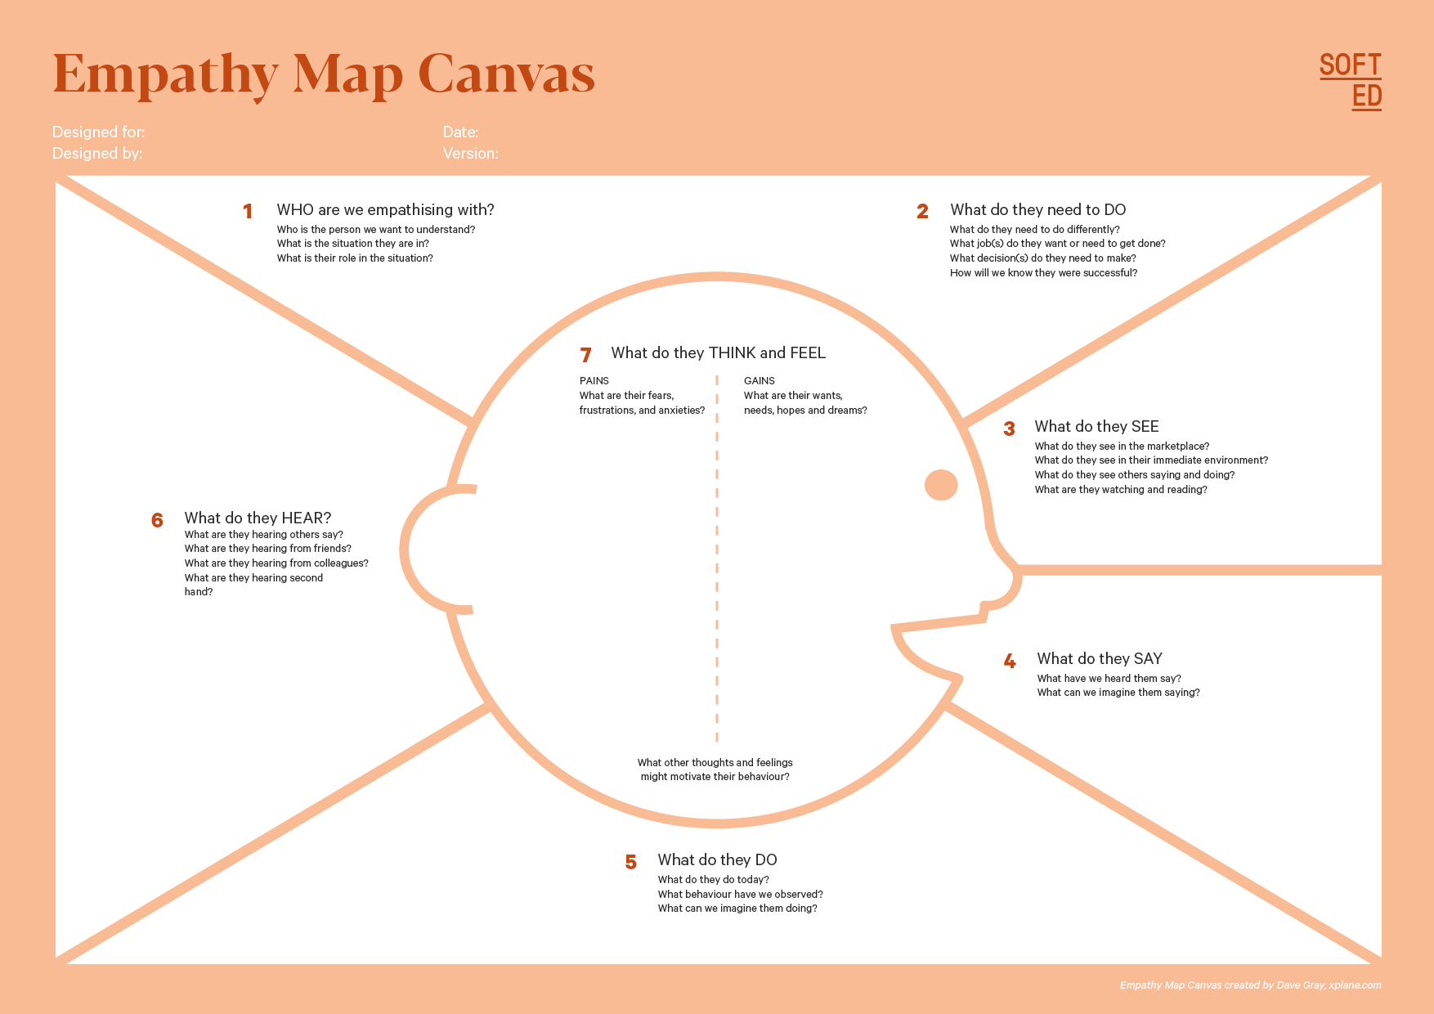

Your Answer:

Your Answer:

Who is your Customer Segment:

Idea/Innovation Title:

Designed By:

Date of Submission:

Your Answer:

Your Answer:

Your Answer:

Your Answer:

Your Answer:

Your Answer:

Your Answer:

1. **Empathy Map**
2. **Who is your Customer?**

The customer is a user who listens to music on streaming platforms and seeks emotional resonance with their song choices. They are typically casual listeners, busy professionals, or individuals using music for emotional support.

**Key points:**

• **Profile:**

* Age: 18-45
* Profession: Students, working professionals, mood-based listeners
* Interests: Music, mental well-being, technology, entertainment

• **Goals & Needs:**

* To find music that fits their mood or emotional state quickly and easily.
* To use music for relaxation, motivation, or emotional healing.

• **Context of Interaction:**

* Users will engage with the solution while browsing music platforms, during moments of emotional need, or when seeking new music that resonates with their current mood.

1. **Who are we empathizing with?**

**Description:** The user is someone who regularly listens to music but often feels overwhelmed by the variety of options and struggles to find songs that truly match their emotions.

**Key points:**

• **Characteristics:**

* Personality: Open to technology, seeks emotional connection through music, values time efficiency.
* Values: Enjoyment, mental well-being, emotional expression.
* Responsibilities: Balancing personal and professional life, managing stress, emotional well-being.

• **Goals & Challenges:**

* Goal: Find music that mirrors their emotional needs without wasting time.
* Challenge: Current systems are broad and impersonal, making it hard to discover the right music for the right emotional moment.

• **Broader Situation:**

* Users often have busy lives and turn to music as a form of emotional escape, stress relief, or inspiration.

1. **What do they need to DO?**

**Description:** Users need to discover emotionally resonant music easily and quickly, without feeling frustrated or overwhelmed by too many irrelevant choices

**Key points:**

• **Tasks or Actions:**

* Find music that aligns with their current mood (e.g., calm, energetic, reflective).
* Trust AI recommendations that understand their emotional state.

• **Decisions:**

* Choosing whether to rely on AI suggestions or manually browse for music.
* Deciding which songs best match their emotional needs.

• **Success Definition:**

* Success is finding music that elevates or complements their emotional state without having to search extensively.

1. **What do they SEE?**

**Description:** The user is surrounded by a digital landscape with numerous music options, playlists, and recommendation systems. They notice the visual clutter of too many choices.

**Key points:**

• **Physical and Digital Environment:**

* Streaming platforms filled with playlists, recommended songs, and new releases.
* Competing apps or features like Spotify’s "Daily Mix" or Apple Music’s "For You."

• **Trends and Competitors:**

* Growing popularity of AI-driven recommendations, personalized playlists, and mood-based music apps.

• **Influences on Behavior:**

* The overwhelming number of options often leads to decision fatigue, pushing users to stick to familiar playlists or genres.

1. **What do they SAY?**

**Description:** In conversations or on social media, users express frustration with current recommendation systems and a desire for more accurate, emotionally-aware suggestions.

**Key points:**

• **Public Feedback:**

* "I can’t find the right music for my mood easily."
* "The recommendations don’t really reflect how I feel right now."

• **Expression of Goals/Frustrations:**

* Users openly express their desire for more personalized and emotionally fitting music experiences.

• **Customer Interviews:**

* "I wish the AI could understand my mood better."

1. **What do they DO?**

**Description:** Users typically follow routines like using familiar playlists or manually searching for songs. They may try mood-based playlists but often find them too generalized.

**Key points:**

• **Observable Actions:**

* Browsing playlists by mood or genre.
* Manually searching for specific songs or artists.

• **Habits or Routines:**

* Using familiar playlists to avoid wasting time.
* Rarely exploring new music due to frustration with generic recommendations.

• **Problem-Solving Actions:**

* When they can’t find the right song, they may settle for something familiar or give up on searching.

1. **What do they HEAR?**

**Description:** Users hear recommendations from friends, media, and platforms about popular playlists or new AI-driven tools for music discovery.

**Key points:**

• **External Sources:**

* Recommendations from friends, online reviews, and social media about new music or features.

• **Media Exposure:**

* Ads or articles promoting music streaming features or new AI-driven innovations.

• **Influencers:**

* Friends, social influencers, and music critics play a role in shaping user preferences.

1. **What do they THINK and FEEL?**

**Description:** Users feel a mix of excitement when they find the right music, and frustration when they can’t. They worry about wasting time and feel disappointed when recommendations miss the emotional mark.

**Key points:**

• **Fears, Worries, and Anxieties:**

* Fear of wasting time trying to find the right music.
* Anxiety about not having an emotionally satisfying music experience.

• **Motivations and Desires:**

* Desire for music that resonates deeply with their emotions.
* Motivation to use music as a tool for stress relief and emotional balance.

• **Alignment of Thoughts and Actions:**

* Though users want emotionally relevant music, they often end up settling for less due to poor recommendations or lack of time.

1. **Pains and Gains**

**Description:** This section highlights the user’s pain points, such as difficulty finding emotionally relevant music, and the gains they seek, like a seamless, emotionally personalized listening experience.

**Key points:**

* **Pains:**
  + Frustration with broad, irrelevant recommendations.
  + Time wasted searching for the right songs.
* **Gains:**
  + Effortless discovery of music that perfectly matches their emotions.
  + A more satisfying, emotionally connected music experience.

**8. Persona of Stakeholders**

**Stakeholder Name:** Priya S., Casual Music Listener

**Goals:**

• To find music that matches her mood easily, especially when she feels stressed after work.

• To discover new music that resonates emotionally, without spending too much time searching.

• To have a seamless, intuitive music experience that helps her relax or focus.

**Challenges:**

* Feeling overwhelmed by the wide variety of music options available on streaming platforms.
* Difficulty in finding emotionally relevant music that aligns with her specific mood (e.g., anxious, calm, motivated).
* Frustration with recommendation algorithms that often miss her emotional context, making the process feel impersonal.

**Aspiration:**

• To have a personalized, AI-driven music tool that consistently understands her emotional state and offers music that fits perfectly with how she feels.

• Long-term, she hopes for a music discovery system that evolves with her tastes and moods, helping her stay emotionally connected and musically satisfied.

**Needs:**

• An emotionally intelligent music recommendation tool that simplifies her search for mood-specific music.

• Quick and easy access to playlists that match her feelings, without requiring manual searches or extensive browsing.

• A more personalized music experience that feels tailored to her emotional needs, rather than generic suggestions.

**Pain Points:**

• Spending too much time browsing through mood-based playlists, only to find that they don't exactly match her feelings.

• Feeling disconnected from the recommendations given by AI-driven playlists that fail to account for her current emotional state.

• Frustration with the lack of customization and overly broad recommendations that don’t resonate with her personal preferences.

**Storytelling:** After a long and stressful day at work, Priya opens her music streaming app, hoping to find some calming music to help her unwind. She browses through several mood-based playlists but feels that they don’t capture how she truly feels — anxious but in need of relaxation. Disappointed, she settles for familiar songs she has heard before, missing the excitement of discovering something new that could elevate her mood. Priya dreams of an AI-driven music tool that understands her emotions in the moment and recommends the perfect soundtrack to help her decompress after a tough day.

**Solution:**  
The new AI-powered emotional music recommendation tool solves this problem for Priya. By analyzing her emotional inputs and current state, the tool curates personalized playlists that perfectly fit her mood. Priya no longer feels the frustration of scrolling through endless playlists; instead, she feels emotionally connected to the music, helping her relax and focus on what matters.

**Sample:**

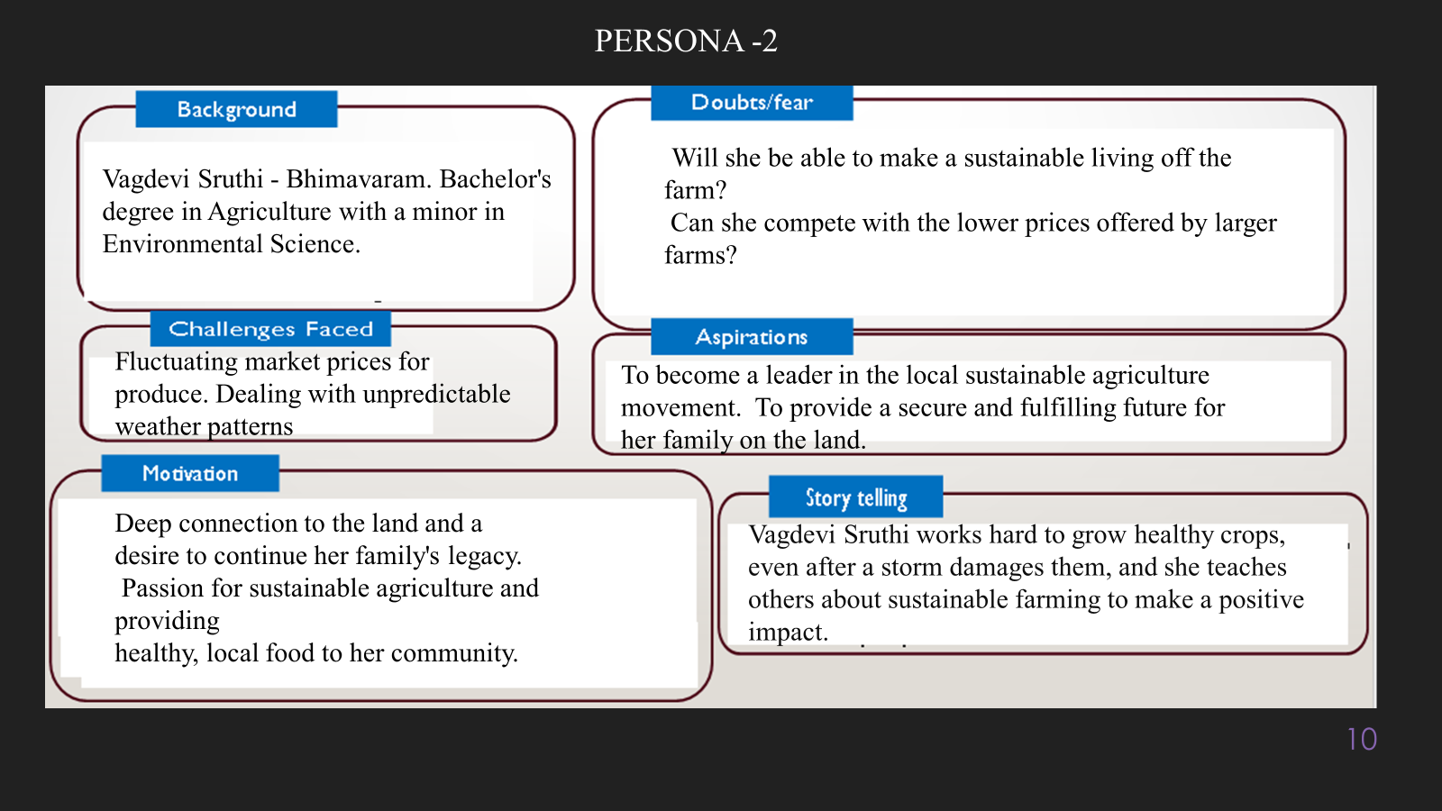

**10. Look for Common Themes, Behaviors, Needs, and Pain Points among the Users**

Analyse the data from your affinity diagram to uncover recurring patterns among your users, helping you better understand their expectations and challenges.

**Common Themes:**

* **Emotional Resonance:** Users consistently express the desire for music that reflects their current emotional state, emphasizing the need for emotional intelligence in music recommendations.
* **Frustration with Algorithms:** Many users feel that current recommendation systems fail to accurately understand their preferences, leading to dissatisfaction with the music suggested.
* **Time Constraints:** Users often have busy schedules, making them seek quick and efficient ways to find music that fits their mood without spending excessive time browsing.

**Common Behaviors:**

• **Searching for Playlists:** Users commonly turn to mood-based playlists or curated lists when seeking music that fits their emotional needs, but they frequently find these options too broad or impersonal.

• **Reverting to Familiar Music:** Due to frustration with finding new music, users often default to familiar songs or playlists, missing out on new discoveries.

• **Experimentation with AI:** Some users express curiosity about AI-driven tools but remain skeptical about their ability to understand nuanced emotions.

**Common Needs:**

* **Personalized Recommendations:** Users need a music recommendation system that can provide personalized suggestions based on real-time emotional input, rather than generic playlists.
* **Ease of Use:** A straightforward, user-friendly interface that allows quick access to relevant music is essential for enhancing the user experience.
* **Emotional Validation:** Users desire music that not only fits their mood but also resonates with their feelings, offering validation and a sense of connection.

**Common Pain Points:**

• **Decision Fatigue:** The overwhelming number of available music options leads to decision fatigue, causing users to feel stressed and frustrated when trying to find the right song.

• **Inadequate AI Understanding:** Users frequently encounter AI systems that do not capture the complexity of their emotional states, resulting in irrelevant recommendations.

• **Time Consumption:** Many users feel that finding suitable music takes too long, diverting them from other activities or causing them to settle for less fulfilling options.

**12. Define Needs and Insights of Your Users**

**User Needs:**

• **Personalized Music Recommendations:**  
Users require a recommendation system that can adapt to their unique emotional states and preferences, providing song suggestions that resonate deeply with their current mood.

• **Ease of Discovery:**  
There is a need for a user-friendly interface that allows users to quickly find music tailored to their emotions, minimizing the time spent searching for suitable tracks.

• **Emotional Connection:**  
Users seek music that not only fits their mood but also validates their feelings. They want songs that provide comfort, motivation, or inspiration, enhancing their emotional well-being.

• **Efficient Access:**  
Users need quick access to playlists or songs that match their emotional needs without the clutter of irrelevant options, enabling them to seamlessly integrate music into their daily lives.

• **Support for Diverse Moods:**  
The solution must cater to a wide range of emotional states, from relaxation and joy to sadness and motivation, allowing users to find the right music for any situation.

**User Insights:**

• **Emotional Resonance is Key:**  
Users are motivated by the desire for emotional resonance in their music choices. They want to feel understood and connected through their listening experience, highlighting the importance of emotional intelligence in recommendations.

• **Frustration with Generic Solutions:**  
Many users express frustration with current recommendation algorithms that fail to capture the complexity of their emotional states. This dissatisfaction drives them to seek alternatives that can better address their needs.

• **Overwhelmed by Choices:**  
The vast amount of available music often leads to decision fatigue. Users find themselves overwhelmed by the options, which discourages exploration and leads to reliance on familiar songs or playlists.

• **Curiosity about AI's Potential:**  
While users are skeptical about AI's ability to understand nuanced emotions, they are also curious and open to exploring AI-driven solutions that promise personalized experiences.

• **Music as an Emotional Tool:**  
Users view music as a powerful tool for emotional regulation and self-expression. Their choices are often influenced by their immediate emotional needs, making it crucial for recommendations to align with these needs.

**13. POV Statements**

**POV Statements:**

* [User] needs a way to [need] because [insight].

|  |  |  |  |
| --- | --- | --- | --- |
| PoV Statements  (At least ten) | Role-based or Situation-Based | Benefit, Way to Benefit,  Job TBD,  Need (more/less) | PoV Questions  (At least one per statement) |
| Casual music listeners need a way to find emotionally resonant songs because they feel overwhelmed by options. | Situation | More tailored recommendations | How can we help users easily discover music matching their emotions? |
| Students need quick access to focus-enhancing playlists because they struggle to find suitable study music. | Role-based | More efficient study sessions | What features will help students quickly find effective focus music? |
| Young professionals need stress-relieving music for commutes because they experience anxiety after work. | Situation | More relaxing commutes | How can we design a selection process that alleviates commuter stress? |
| Music enthusiasts need a personalized recommendation system because they want to discover new artists and genres effortlessly. | Role-based | More engaging music discovery | How can we ensure our recommendations evolve with user preferences? |
| Parents need family-friendly playlists for road trips because they want to avoid repetitive or inappropriate songs. | Situation | More enjoyable trips | How can we curate suitable playlists for kids and adults? |

**14. Develop POV/How Might We (HMW) Questions to Transform Insights/Needs into Opportunities for Design**

Turn your user needs and insights into actionable opportunities by framing them as "How Might We" (HMW) questions. These questions will spark creative problem-solving and guide your innovation process.

1. **How Might We: Based on the needs and insights you've identified, create open-ended questions starting with "How might we...?" These questions should aim to solve user pain points, enhance the experience, or address specific needs.**

**Examples:**

* **User Need: "Users need a quicker way to access customer support."**
  + **HMW Question: "How might we create a more efficient and accessible customer support system?"**
* **Insight: "Users feel overwhelmed by too many options."**
  + **HMW Question: "How might we simplify decision-making for our users?"**

**Task:**

**Write 3-5 "How Might We" questions based on your analysis of user needs and insights. These questions should challenge you to think of innovative solutions that can address user problems in meaningful ways.**

**This task encourages participants to think creatively about solving user problems, transforming challenges into opportunities for innovation.**

|  |  |
| --- | --- |
| User Need/Insight | "How Might We" Question |
| [State the user need or insight clearly] | **How might we... [formulate an open-ended question to address the need or insight]?** |

**16. Crafting a Balanced and Actionable Design Challenge**

The Design Challenge Should Neither Be Too Narrow Nor Too Broad and It Should Be an Actionable Statement with a quantifiable goal. It should be a culmination of the POV questions developed.

**Design Challenge:** [Actionable Statement]

**17. Validating the Problem Statement with Stakeholders for Alignment**

Ensure your problem statement accurately represents the needs and concerns of your stakeholders and users. This involves gathering feedback from these groups to confirm that the problem is relevant and significant from their perspective. By validating early, you can refine the problem statement to better align with real-world challenges, ensuring your solution addresses the correct issues.

**Validation Plan:**

**Stakeholder/User Feedback (Min. 10 Stakeholders/Experts):**

|  |  |  |  |  |
| --- | --- | --- | --- | --- |
| Stakeholder/User | Role | Feedback on Problem Statement | Suggestions for Improvement |  |
| [Music Listener Group] | Casual Listeners | The problem resonates as they often feel overwhelmed by the vast music choices. | Simplify the language to focus more on emotional connection and less on "overwhelming" choices. |  |
| [Music Enthusiasts] | Music Bloggers | The problem reflects their desire for personalized discovery tools. | Highlight more on discovering new artists, genres, and experiences. |  |
| [Student Association] | University Students | The problem resonates, especially with difficulty finding suitable music for concentration. | Emphasize the need for quicker access to study-related playlists. |  |
| [Commuters Group] | Daily Commuters | They agree the problem reflects their need for stress-relieving music during commutes. | Add a note about timing music suggestions to specific moments of the commute. |  |
| [Parents Group] | Working Parents | They resonate with the need for family-friendly playlists on long drives. | Mention the balance of kid-friendly and adult-appealing music. |  |
| [Fitness Trainers] | Personal Trainers | The problem somewhat resonates, but focus more on energy-based music curation. | Include scenarios like workout sessions where music intensity adapts. |  |
| [Mental Health Advocates] | Well-being Experts | They believe the problem is relevant for promoting emotional well-being through music. | Focus on the impact of music on mental health improvement more clearly. |  |
| [Tech Developers] | AI Developers | The problem is technically feasible but needs clearer definitions of emotional metrics. | Define "emotional resonance" in terms of measurable AI inputs for clarity. |  |
| [Event Organizers] | Music Event Planners | They see a potential to extend the problem to live music discovery for local experiences. | Mention integration with local events and performances to enhance community engagement. |  |
| [Streaming Service Providers] | Music App Developers | They agree with the problem but suggest aligning it with current trends in music streaming. | Add a focus on user engagement and retention via emotional connections. |  |
|  |  |  |  |  |

**18. Ideation**

**Ideation Process:**

|  |  |  |  |
| --- | --- | --- | --- |
| Idea Number | Proposed Solution | Key Features/Benefits | Challenges/Concerns |
| Idea 1 | Emotion-based music recommendation engine | Recommends music based on users' emotions via real-time feedback | Accurately detecting emotional states may be challenging; privacy concerns with emotional data |
| Idea 2 | Quick-access mood playlists for various activities (e.g., study, commute, workout) | Saves time for users, provides curated playlists for specific activities | Ensuring variety in playlists and keeping them updated regularly |
| Idea 3 | AI-driven music discovery for new artists and genres | Helps users discover fresh music tailored to their evolving preferences | Balancing mainstream vs. niche recommendations, avoiding overwhelming users with options |
| Idea 4 | Family-friendly playlist builder for road trips | Generates playlists with a mix of kid-friendly and adult-suitable songs | Difficulty balancing content for diverse age groups; licensing issues for certain tracks |
| Idea 5 | Localized music event integration with streaming service | Connects users to local music events and live performances based on their preferences | Ensuring real-time updates on events; integrating with third-party event organizers |

**18. Idea Evaluation**

Evaluate the Idea based on 10/100/1000 grams

|  |  |  |  |  |
| --- | --- | --- | --- | --- |
| Idea | Impact (10/100/1000 grams) | Feasibility (10/100/1000 grams) | Alignment (10/100/1000 grams) | Total Weight |
| **Idea 1:** Emotion-based music recommendation engine | 1000 | 100 | 1000 | 2100 |
| **Idea 2:** Quick-access mood playlists for activities | 100 | 1000 | 100 | 1200 |
| **Idea 3:** AI-driven music discovery for new artists and genres | 100 | 100 | 100 | 300 |
| **Idea 4:** Family-friendly playlist builder for road trips | 100 | 1000 | 100 | 1200 |
| **Idea 5:** Localized music event integration with streaming service | 1000 | 100 | 1000 | 2100 |

**Example:**

|  |  |  |  |  |
| --- | --- | --- | --- | --- |
| Idea | Impact (10/100/1000 grams) | Feasibility (10/100/1000 grams) | Alignment (10/100/1000 grams) | Total Weight |
| Idea 1 | **1000** | **100** | **1000** | **2100** |
| Idea 2 | **100** | **1000** | **100** | **1200** |
| Idea 3 | **100** | **100** | **100** | **300** |

Further, use solution concept form to scrutinize the idea

**Solution Concept Form**

* 1. **Problem Statement:**
* • Users struggle to find music that matches their emotional state due to the overwhelming volume of options available on streaming platforms, leading to frustration and wasted time.

**2. Target Audience:**

* The main users are casual music listeners, mood-based users, and those seeking emotionally resonant music for specific emotional needs, such as stress relief or mood enhancement.

**3.Solution Overview:**

An AI-powered music recommendation engine that uses emotional feedback from users to curate personalized playlists based on their current feelings or mood, simplifying music discovery.

**4. Key Features:**

| **Feature** | **Description** |
| --- | --- |
| **Feature 1:** Emotion Detection | The AI detects user emotions through simple feedback (e.g., emoji, slider) or physiological data (optional), adapting playlist recommendations accordingly. |
| **Feature 2:** Mood-based Playlists | Automatically generated playlists tailored to specific moods like "relaxed," "energized," or "focused." |
| **Feature 3:** Continuous Feedback Loop | Users can provide real-time feedback to further refine the music selection based on their changing emotions or preferences. |

**5. Benefits:**

| **Benefit** | **Description** |
| --- | --- |
| **Benefit 1:** Personalized Experience | Provides a highly personalized music experience based on real-time emotional input, enhancing user satisfaction. |
| **Benefit 2:** Simplified Music Discovery | Reduces the time spent searching for the right music by offering curated playlists tailored to users’ emotional needs. |
| **Benefit 3:** Emotional Well-being | Helps users regulate their emotions and improve their mood by offering music aligned with their current state. |

**6. Unique Value Proposition (UVP):**

This solution uniquely combines emotional intelligence with music recommendation, offering users an intuitive way to discover music that resonates with their emotional needs. The continuous feedback loop ensures ongoing personalization, setting it apart from traditional static playlist recommendations.

**7. Key Metrics:**

| **Metric** | **Measurement** |
| --- | --- |
| **Metric 1:** User Engagement | Measure daily and weekly active users interacting with the emotional feedback feature. |
| **Metric 2:** Playlist Accuracy | Track user feedback on playlist accuracy (e.g., whether the recommended music matched their mood). |

**8. Feasibility Assessment:**

• The solution is feasible with current AI technology and streaming data integration. However, emotional data collection (e.g., physiological sensors) could be more challenging and should be considered as an optional feature. The initial version can focus on manual emotional feedback (e.g., via emojis or text inputs).

**9. Next Steps:**

• Prototype development of the emotion-based recommendation engine. • User testing with real-time emotional feedback to refine the accuracy of playlist suggestions. • Integration with popular music streaming platforms to leverage existing music libraries and user data.